**BEGINNING OF TERM ONE INTERNAL EXAMINATIONS 2024**

**PRIMARY FIVE**

**MATHEMATICS**

Time allowed: **2** hours **30** minutes

**Name:** ____________________________________________________________

**Signature:** _________________________________________________________

**DO NOT OPEN THIS BOOKLET UNLESS YOU ARE TOLD TO DO SO**

**FOR EXAMINERS’ USE ONLY**

|  |  |  |
| --- | --- | --- |
| **Qn. No.** | **Marks** | **Exr’s No.** |
| **1 – 5** |  |  |
| **6 – 10** |  |  |
| **11 – 15** |  |  |
| **16 – 20** |  |  |
| **21 – 22** |  |  |
| **23-24** |  |  |
| **25-26** |  |  |
| **27-28** |  |  |
| **29-30** |  |  |
| **31-32** |  |  |
| **TOTAL** |  |  |

**Read these instructions carefully;**

1. The paper has two sections **A** and **B**

2. Section **A** has **20** questions (**40 marks**)

3. Section **B** has **12** questions (**60 marks**)

4. Answer all questions. All the working for both sections A and B must be shown in the spaces provided.

5. All answers must be written with **blue** or **black**

**ball-point pen** or in **ink**. Only diagrams and graph work must be done in pencil.

6. No calculators are allowed in examination room.

7. Unnecessary alteration of work and any **handwriting** that cannot easily be read may lead to loss of marks.

8. Do **not** fill anything in the boxes indicated;

**“FOR EXAMINER’S USE ONLY"**

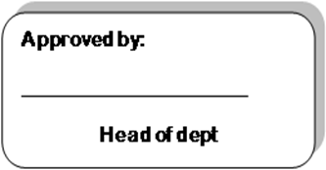

**TURN OVER**

**SECTION A (40 MARKS)**

**Attempt all questions in this section.**

**Each question carries 2 marks**

1. Add: 413207 + 324581

2. What is **¾** of 8?

3. Bosco bought a soda at Sh. 1000 and a bread at Sh. 2500. How much did he pay?

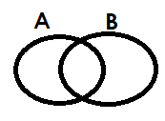4. Shade A – B

5. Change **18/5** to a mixed fraction.

6. Solve m + 2 = 5

7.Write 125 in Roman numerals.

8. How many half litre cups can be got from 5 litre bucket?

9. Collect like terms. 8m + 7k – 3m - 2k.

10. Add 1/3 + ½

11. What is the difference between Sh. 8700 and Sh. 6200?

12. In the space below draw a parallelogram.

13. Reduce 5/10 to the lowest terms.

14. How many Sh. 500 coins can be got from Sh. 2000?

15. If set R = {the first 4 prime numbers} Find n (R)

16. Write 909,908 in words.

17. Find the next equivalent fraction to **¾**.

18. Expand 75.83 using powers.

19. Workout: Hrs min

2 5 0

+ 3 4 0

20. Shade 2/3 of the diagram.

**SECTION B (60 MARKS)**

**Answer all questions in this section**

**Marks for question are indicated in brackets.**

21. Given that n(M) = 25, n(N) = 30 and n(MnN) =10

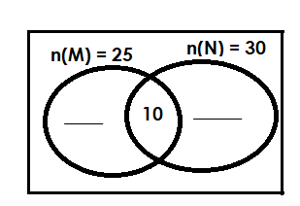a) Complete the Venn diagram below.

(2mks)

b) Find n(M u N) (2mks)

c) Find n(M n N)**1**  (2mks)

22. Given the digits 1,7,3,9 and 7.

a) Write the smallest number that can be formed using the digits above.

(1mk)

b) Write the largest number that can be formed using the digits above.

(1mk)

c) What is the sum of the largest and the smallest number formed?

(2mks)

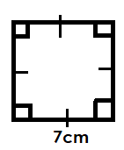23. Study the shape and answer questions about it.

a) Name the shape.

(1mk)

b) Calculate the area of the shape. (2mks)

c) Workout the total distance around the shape. (2mks)

24. Workout the following (2mks) each.

a) X + 7 = 15

b) 3m = 12

c) a/4 = 2

25. Given the number 999,999.

a) Write the number above in words. (2mks)

b) Expand the number above. (2mks)

c) Round off the number above to the nearest tens. (2mks)

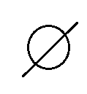26 (a) Name the set symbols below. (1mk) each

______________________

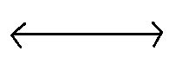

_____________________

b) How many subsets are in a set of 3 elements? (2mks)

27(a) Find the lowest common multiple (L.C.M) of 6 and 9. (2mks)

b) Workout the square of 5.

(1mk)

c) Find the greatest common factor (G.C.F) of 12 and 8. (2mks)

28.(a) Gabriel went to the village for 4 weeks. What time in days is he going to spend in the village? (2mks)

b) Express 3 metres as centimetres. (2mks)

c) How many grams are in 1 kilogram? (1mk)

29(a) Express 51/2 as an improper fraction. (2mks)

b) Workout ¾ - 1/3. (2mks)

30. Kule went shopping and bought the following items.

2kg of sugar at Sh.3200 per kg

1kg of meat at Sh. 13000 per kg

3kg of rice at Sh. 5000 per kg

a) Calculate for the total expenditure.

b) If she had a fifty thousand shillings note. Find his change.

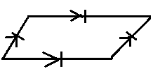31.(a) Name the following shapes. (1mk) each

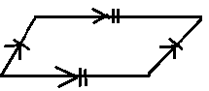

___________________________ __________________________

____________________________

b) Draw the following shapes (1mk) each

i) Tetrahedron ii) cube

32. Using a ruler, apencil and a pair of compasses only. Construct a triangle of side 6cm all around. (4mks)

b) Workout its perimeter (1mk)